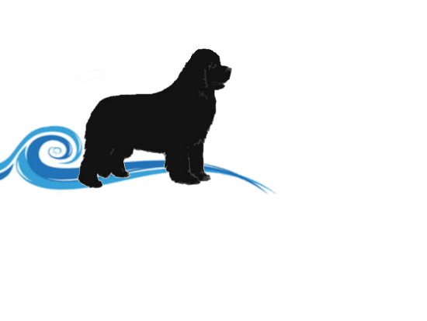
Niangua River Newfoundlands
www.nianguarivernewfs.com
122 Chicago Road, Elkland, MO 65644
(417) 531-3716
Email: nianguarivernewfs@gmail.com
Facebook.com/nianguarivernewfs

Date of Transfer __________________ Puppy AKC Number: _________________________
Puppy DOB ______________ Breed__________________________ M / F Color ______________________
Sire: _________________________________________ Dam: ___________________________________________
Buyer(s): _______________________________________________________________
Address: _______________________________________________________________________________________
Phone #: _______________________________________________________________
Email:__________________________________________________________________

NOTE Deposits are NON REFUNDABLE Forms of payment accepted cash or paypal ONLY. Personal checks accepted for deposits only.
Within 7 days of receiving puppy buyer needs to have puppy examined by a LICENSED veterinarian. If the Veterinarian finds the puppy in ill health (cause of which is attributed to the seller) the seller must be notified within the 7-day period. Seller requires a written statement from Veterinarian.
Seller will have the puppy re-examined by seller’s Vet and if verification is obtained that puppy is in life threatening health the seller will then offer a full refund of the cost of the puppy (traveling or shipping expenses are not covered by the seller). It is the buyer’s responsibility to return the puppy to the seller.
Microchip # ______________________________________________________-
We offer a Genetic Health Guarantee for puppies up to one year of age intended for serious life threatening health issues and genetic diseases. If found to be the case you will be given another puppy of equal value at the time one becomes available. Seller has the right to request the return of the puppy. This health guarantee does not cover minor health conditions that are common to the breed such as ear infections, etc., allergies, parasites, or any ailments brought on due to environment/stress.
This guarantee will be considered VOID if buyer neglects to follow through with ALL the required puppy vaccinations and worming schedule etc… by a Licensed Veterinarian. Seller has the right to ask for vet records if needed for this genetic health guarantee.
By signing below buyer agrees he/she has read and understands this contract and understands the terms of the purchase agreement and pre-arranged shipping and delivery terms: ____________________________________________________
____________________________________________________________________________________________________

Buyer Signature ______________________________________________________________ Date __________________
Seller Signature ______________________________________________________________ Date___________________

