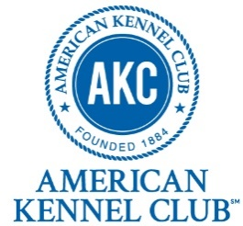
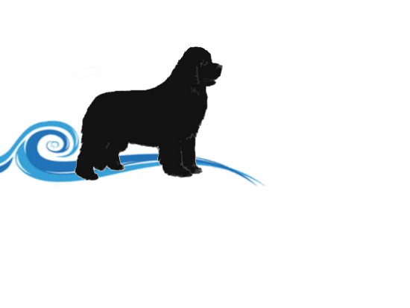
Niangua River Newfoundlands
122 Chicago Road, Elkland, MO 65644
(417) 531-3716
Email: nianguarivernewfs@gmail.com
Facebook.com/nianguarivernewfs
Website www.nianguarivernewfs.com

Health Guarantee
Brian and Jennifer Clasby of Niangua River Newfoundlands (hereinafter referred to as Breeder) enters into this agreement with _____________________________________________ (hereinafter referred to as Owner) on ________________for the purchase of a purebred, AKC registered Newfoundland Dog.
Puppy / AKC Number: ______________________________________ Puppy DOB ______________
Breed__________________________ M / F Color ______________________

Niangua River Newfoundlands certifies that the puppy you purchased is in sound health at the time of sale to the best of our knowledge and has been given all vaccines and deworming stated on the treatment and vaccination record provided to you. We have done our best to provide you with a healthy puppy. You are responsible for further vaccinations and boosters and regular deworming.
We strongly recommend, but do not require, that your puppy be spayed or neutered. It is your ultimate responsibility to take good care of your puppy and provide adequate food, water, shelter, and veterinarian care. We have bred this puppy based on sound stock. Through proper diet, exercise, and quality living conditions, you can play an important role in helping your puppy grow into a healthy adult.
Please be aware that as a new puppy owner you share in the responsibility to help prevent hip dysplasia, as it has been proven to be partly hereditary and increasingly environmental.
- Owner agrees to the following conditions upon purchase:
  - That Newfoundland is being purchased with full intention to provide a caring home and healthy environment for the duration of the dog’s lifespan. Owner agrees to provide proper care and treatment specific to the needs of the breed for optimal health.
  - Newf shall receive proper veterinarian care necessary for the health and welfare of the dog.
  - Newf is never to be left chained outdoors or knowingly allowed to roam unattended.
  - Owner agrees to return dog to Breeder if at any time Owner cannot provide adequate care for the dog. Owner agrees Newf will never be placed in a shelter at any time. If Owner returns the dog, Owner agrees to provide Newf’s AKC registration papers signed over to Breeder.
  - Owner agrees not to allow Newf, or any puppies resulting from a breeding of Newf to be raffled off, or sold, or consigned to pet shops, brokers, or animal wholesalers.
  - Owner agrees to provide a picture and update of pup at one year of age to breeder by email or mail.

- Breeder agrees to the following upon purchase:
  - Breeder warrants that Owner is buying a purebred Newfoundland Dog and that they will furnish Owner with Newf’s AKC registration papers after final payment has been received or upon picking up puppy.
  - Breeder guarantees Newf has had proper care to date and is in good health as it leaves our possession. Breeder also agrees to provide Owner with a certificate of health from a licensed Veterinarian as well as health records including shots, de-worming, development, and nutrition schedule. Puppies will be current in all vaccinations and de-worming and receive a final puppy wellness exam by a licensed Veterinarian before transfer of ownership.

Two Week Health Warranty
You are responsible to have your puppy examined by a veterinarian within two weeks of the purchase date. Any claims that the puppy is not healthy within the two-week warranty period must be backed up by two unaffiliated veterinarians. In the event two unaffiliated veterinarians certify that the puppy has internal parasites or a contagious illness the puppy was vaccinated against, or a health issue of such serious nature that the quality of life of the dog will be shortened or seriously altered, Niangua River Newfoundlands will reimburse your reasonable and customary veterinary bills related to treatment of the condition up to the purchase price of your puppy.
We cannot control the exposure your puppy encounters after the sale and do not guarantee against ticks, fleas, or ear mites. Furthermore, Niangua River Newfoundlands offers no warranty against stress induced conditions. Puppies sometimes get stressed when they are adopted and move to their new home. This stress can be brought on due to the move, change in diet, too much handling, not enough quiet time, or not eating properly. Stress can bring on minor health ailments including but not limited to diarrhea, constipation, colds, and hypoglycemia. After-sale exposure and stress related conditions do not warrant reimbursement for treatment.
We cannot control or guarantee the size of the puppy now or as an adult nor can we guarantee breed characteristics. This health guarantee does not cover minor health conditions that are common to the breed such as ear infections, etc., allergies, parasites, or any ailments brought on due to environment/stress.

One Year Genetic Warranty
If in the first year of your puppy’s life a genetic disease is discovered that will greatly shorten the life of or greatly alter the quality of your puppy’s life then we will reimburse you for veterinary costs related to the treatment of the genetic disease up to the purchase price of the puppy. Alternatively, if you wish, we will replace your puppy or issue a credit for a future puppy. If you choose puppy replacement, we will not reimburse any veterinary expenses. The following stipulations must be adhered to for a replacement or reimbursement to be made:
1. Buyer must provide documentation from a licensed veterinarian stating the puppy has a genetic defect or health condition that is life threatening. The report must include the phone number of the veterinarian’s office. Breeder reserves the right to confirm the diagnosis of a genetic defect with a veterinarian of our choice.
2. In the event of the puppy’s death, an autopsy must be done by a licensed veterinarian stating the cause of death. The documentation must be forwarded to us along with the phone number of the veterinarian before a determination will be made.

Agreement
All warranties apply only to the original buyer. Under no circumstances will Niangua River Newfoundlands be liable to a third party. Any disputes, mediation or legal proceedings will take place in the state of Missouri. The parties agree that this represents a full and complete understanding of the warranties and responsibilities of the parties to this sale
By signing below buyer agrees he/she has read and understands this contract and understands the terms of the purchase agreement and pre-arranged shipping and delivery terms.
Buyer Signature ______________________________________________________________Date __________________
Breeder Signature ____________________________________________________________ Date___________________

